**Ex. No : 1 B**

**Date : 23.01.2025**

**IMPLEMENT CLIENT SIDE FORM DESIGN AND VALIDATION**

**AIM:**

To implement client side form design and validation to use GET and POST HTTP request.

**PROCEDURE:s**

|  |  |  |
| --- | --- | --- |
| **S.NO** | **HTML TAGS** | **DESCRIPTION** |
| **1** | **<html>** | **The html tag in HTML is used to define the root of HTML and XHTML documents.** |
| **2** | **<a herf=” “> …</a>** | **create a hyperlink on the webpage.** |
| **3** | **<button type = “button”>** | **define the clickable button** |
| **4** | **<code>** | **define the piece of computer code.** |
| **5** | **<div>** | **make divisions of content in the web page** |
| **6.** | **GET** | **GET is used to request data from a specified resource** |
| **7** | **POST** | **POST is used to send data to a server to create/update a resource.** |

**SOURCE CODE :**

<!DOCTYPE html>

<html lang="en">

<head>

<meta charset="UTF-8">

<meta name="viewport" content="width=device-width, initial-scale=1.0">

<title>Stack Overflow Form</title>

<!-- <link rel="stylesheet" href="./StyleSheet/form.css"> -->

</head>

<body>

<h1>Redux Overflow Form</h1>

<form action="welcome.html" method="get">

<label for="username">Username:</label><br>

<input type="text" id="username" name="username" required><br><br>

<label for="email">Email:</label><br>

<input type="email" id="email" name="email" required><br><br>

<label for="password">Password:</label><br>

<input type="password" id="password" name="password" required><br><br>

<label for="birthdate">Birthdate:</label><br>

<input type="date" id="birthdate" name="birthdate" onchange="showDate()"><br>

<p id="selected-date"></p><br><br>

<label for="country">Country:</label><br>

<select id="country" name="country">

<option value="us">United States</option>

<option value="uk">United Kingdom</option>

<option value="india">India</option>

<option value="other">Other</option>

</select><br><br>

<label for="question">Your Question:</label><br>

<textarea id="question" name="question" rows="4" cols="50" placeholder="Type your question here..."></textarea><br><br>

<label>Tags:</label><br>

<input type="checkbox" id="javascript" name="tags" value="JavaScript">

<label for="javascript">JavaScript</label><br>

<input type="checkbox" id="python" name="tags" value="Python">

<label for="python">Python</label><br>

<input type="checkbox" id="html" name="tags" value="HTML">

<label for="html">HTML</label><br><br>

<label for="upload">Upload File:</label><br>

<input type="file" id="upload" name="upload" onchange="showFileSize()"><br>

<p id="file-size"></p><br><br>

<label for="rating"></label><br>

<input type="range" id="rating" name="rating" min="1" max="10"><br><br>

<label for="time">Preferred Time for Support:</label><br>

<input type="time" id="time" name="time"><br><br>

<input type="submit" value="Submit">

</form>

<script>

// Function to display selected date

function showDate() {

var birthdate = document.getElementById("birthdate").value;

document.getElementById("selected-date").innerText = "Selected Date: " + birthdate;

}

// Function to display file size

function showFileSize() {

var fileInput = document.getElementById("upload");

var file = fileInput.files[0];

if (file) {

var fileSize = (file.size / 1024).toFixed(2); // Size in KB

document.getElementById("file-size").innerText = "File Size: " + fileSize + " KB";

} else {

document.getElementById("file-size").innerText = "";

}

}

</script>

</body>

</html>

**OUTPUT 1 :**

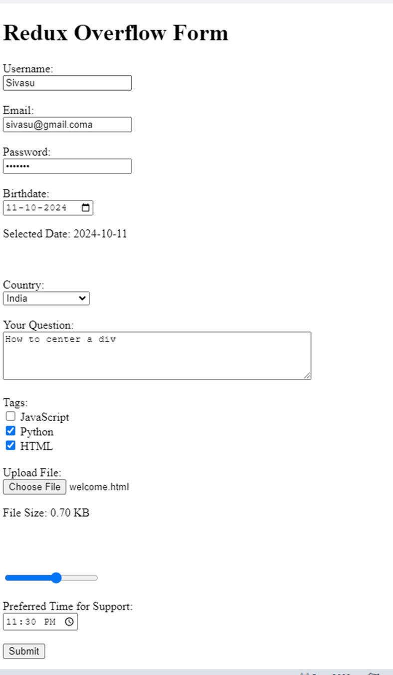

**OUTPUT 2:**

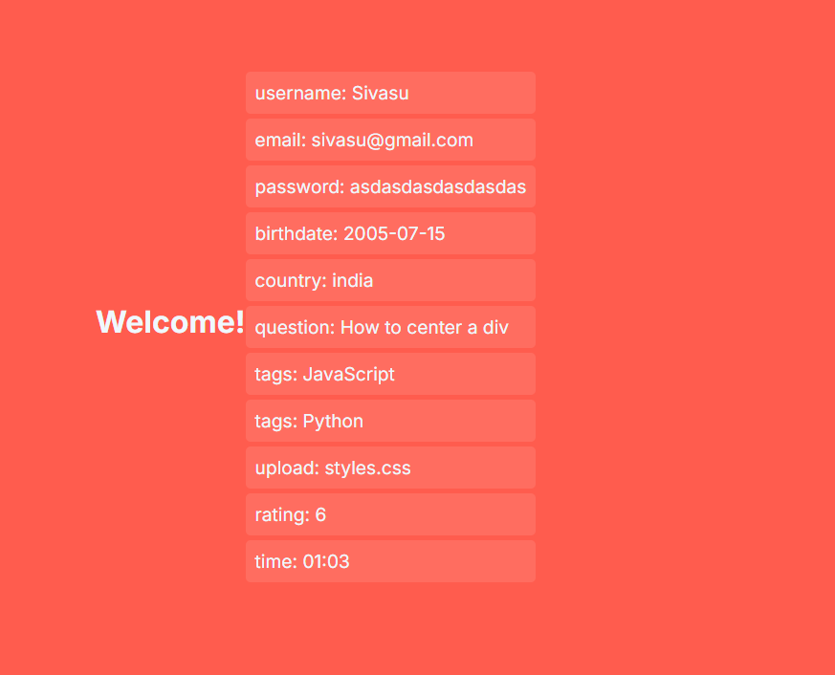

**OUTPUT 3:**

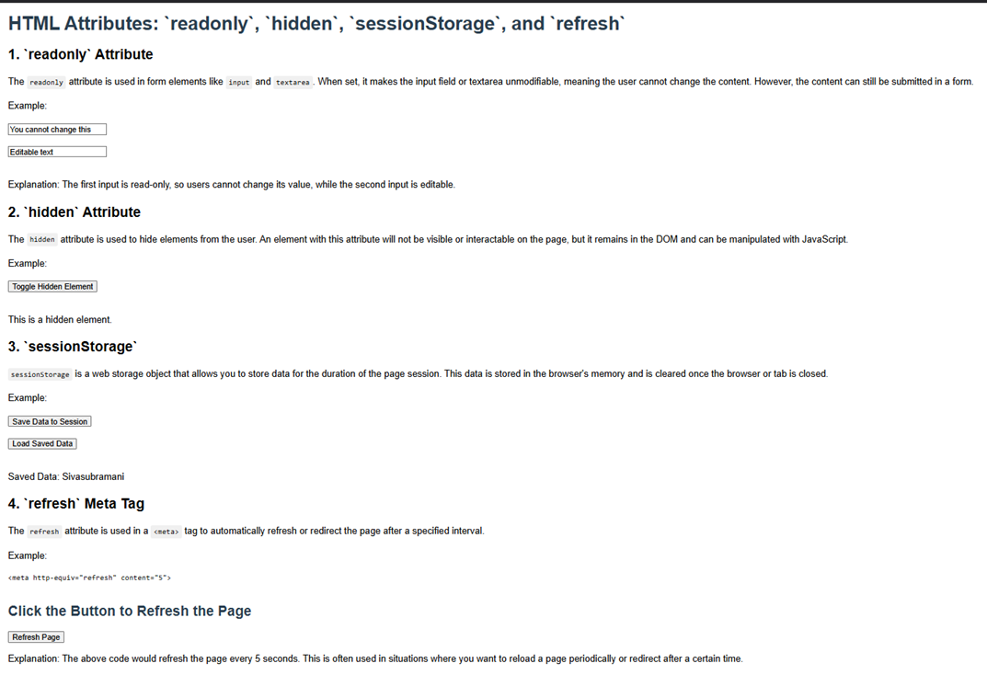

**RESULT :**

The program has been successfully executed and the output is verified.